The Catacomb Classic

Montresor lets out his last truth along with his last breath.

Reporter : Emely Rosales

Montresor calls for me
That morning I had a feeling, one of those gut feelings that caused the hairs on the back of my neck to stand and my stomach to turn to knots. No, I did not know what was to come later that day, but I knew for certain it wouldn't be good.
Shortly after I began my morning, I received the call. Little did I know, this call would change my life forever. The call was from the one and only, Montresor, the last man seen to have interacted with the jester who mysteriously disappeared who went by the name of Fortunato. When I asked why he had called, he told me with a broken voice, he wanted to confess something to the world before he passed away on his deathbed, he wanted to say it before he no longer could. I then agreed to meet him and hear his words before he died and the following is what he admitted to me.

Montresor's story

Once I arrived. As I entered the depressing and suspenseful room that awaited his demise. I made eye contact with the man himself, Montresor. He looked me dead in the eye with what felt as though a look with Muse in his eyes as he pondered the words he would speak next. I sat down and introduced myself and shook his hand. If only I knew what words were going to escape his lips during this encounter. He weakly looked up at me and told me that what he was about to say was not to be made into anything less than what it was.

He began by telling me he got revenge on his greatest adversary. I asked him who his greatest adversary was and though he told me as though it was negligible, he whispered to me that his greatest adversary was the missing jester, Fortunato. As he saw me gape in reaction to the mysterious words he had whispered to me, he then explained what happened that night.

“The Thousand injuries of Fortunato I had borne as I best could, but when he ventured upon insult I vowed revenge,” he uttered this as though he was in a trance of some sort, telling me this was why Fortunato was his greatest adversary.

“ He had a weak point this--Fortunato--although in other regards he was a man to be respected and even feared. He prided himself on his connoisseurship in wine… I was skillful in the Italian vintages myself and bought largely whenever I could,” Montresor explained how he found Fortunato's weak points including his excessive drinking and took that to his advantage for his revenge against him. He also used Fortunato's jealousy of the towns other amontillado connoisseur, Luchresi, to lead him to where he wanted him, in the vault out of imposture.

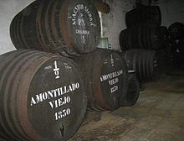

He told me that he had him going where he wanted through the catacombs where it was dark and far away and no one would be able to hearken them, “ we had passed through long walls are piled skeletons with casks and puncheons intermingling into the inmost recesses of the Catacombs.”

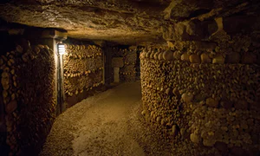

“ At the most remote end of the crypt there appeared another less spacious... it seemed to have been for no special use within itself, but formed nearly the interval between two of the Colossal supports of the roof of the Catacombs, and was backed by one of their circumscribing walls of solid granite,” he told me he used this and told Fortunato that there lied the pipe of amontillado so he would take a closer look inside. “ proceed, I said; herein is the Amontillado… a moment more and I had fettered him to the Granite.”
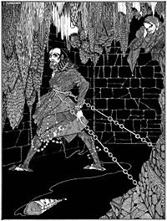

He told me what happened after he chained Fortunato to the granite and started walling him in , “ A succession of loud and shrill screams, bursting suddenly from the throat of the change form, seem to thrust me violently back… I reproach the wall I replied to the yells of him who clamoured. I re-echoed, i aided, I surpassed them and volume and in strength.”

These were his confessions to me before he died, why did he want the world to know?, was he mentally insane?, did he ever regret his actions? I don't know but i have my suspicions, this is what he shared with me and now im sharing it with you. Montresor lived a secret and mysterious life and even though he confessed before he died, we are all kept wondering why.

